**ASSIGNMENTS – DAY 2**

**1. Create React JS Notes App using Redux(AddNote, DeleteNote) similar to this**

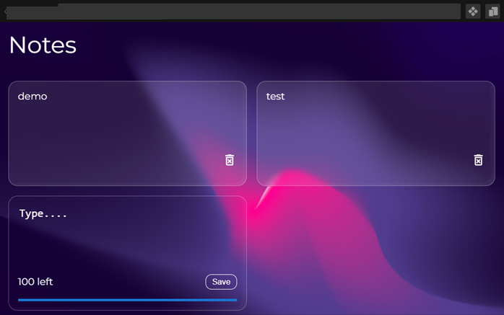

1. **Implement the CRUD operations using local JSON Server for Student App(Day 1) (Using Fetch or Axios)**
2. **Use the React-Hooks sample create app Product demo(AddProduct, RemoveProduct) connect with the local storage**